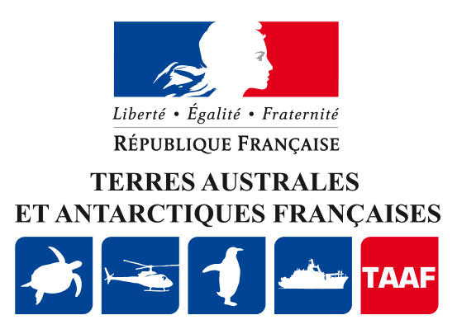
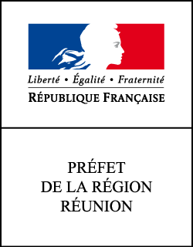

Press release
Saint-Denis
Le 12 mars 2019

Call for projects – ‘Elsewhere’ workshop 5
Creative residency in the French Southern and Antarctic Territories

_____________________________________________________________________

The Administration of the French Southern Antarctic Territories (TAAF) and the French Ministry of Culture, Division of Cultural Affairs in Reunion (DAC) are launching the 2019 / 2020 edition of Atelier des Ailleurs 5 (‘Elsewhere’ Workshop 5), an exceptional creative residency in the French Southern and Antarctic Territories (Crozet, Kerguelen and Amsterdam). The residency, which will welcome two artists working simultaneously, is organised by the Regional Contemporary Art Fund (FRAC Reunion).
An exceptional residency
The aim of the project is to place contemporary creation within the context of these territories, totally remote from human activity. Today, the conservation of the natural environment and climate change are essential challenges and a source of inspiration for artistic and creative activity. The ‘Elsewhere’ workshop, a unique opportunity to return to the secular notion of the voyage of discovery, will enable the two artists selected to relocate their artistic practice to a unique setting for creation and research. More widely, it is the opportunity for both scientists and artists to reflect on their respective processes.
Call for projects 2019/2020
The call for projects 2019/2020 is addressed to artists working in the field of the performing arts and wishing to have an extraordinary creative experience in the French Southern and Antarctic Territories, lasting approximately 3 months between December 2019 and April 2020.
Candidates for the residency must not be put off by the remote environment (the French Southern Islands are situated several days by ship from Reunion Island), nor by the lack of Internet connections or mobile telephones and must be in good health.

The artists retained will stay on one of the French Sub-Antarctic bases (Port-aux-Français on Kerguelen, Alfred Faure on Crozet or Martin de Viviès on Amsterdam), where work is carried out in the fields of French sovereignty, scientific research and preservation of the natural environment.
Each of the two artists selected will receive a fixed-sum grant of 6,000 euros.
The artist reserves the right for the DAC, TAAF and FRAC of Reunion to present a preview of work carried out in the context of this residency.
Within two years following the residency, the artist will give a presentation of his or her work on Reunion Island, at a specified performance venue. The DAC can provide support as regards identification of performance venues and contribute to the costs of the performance.
Application forms and regulations can be consulted on the website of the DAC Reunion http://www.culture.gouv.fr/Regions/Dac-de-La-Reunion,
the French government website http://www.reunion.gouv.fr or that of the TAAF (www.taaf.fr)
Applications to be addressed to the DAC, Reunion, by post only, to the attention of Natacha Provensal, museum and arts adviser to the following address:
Direction des affaires culturelles de La Réunion
‘Atelier des Ailleurs 5’
23 rue Labourdonnais
CS 71045
97404 Saint Denis Cedex

Applicants are invited to the obtain information on the various southern territories of the TAAF (Crozet, Kerguelen, Saint-Paul and Amsterdam) and to situate their project in the context of one of these territories.
The deadline for reception of application files is Friday, 31 May 2019 the post-office stamp attesting the date of expedition
Contacts
DAC de La Réunion
Conseillère pour les musées et les arts plastiques : natacha.provensal@culture.gouv.fr
Communication et médias : francoise.kersebet@culture.gouv.fr
TAAF
Communication : nelly.gravier@taaf.fr

